

**National University of Computer & Emerging Sciences (FAST)**

PromoLac

**Location-Based E-Marketing App**

**Project Supervisor**

**Mr. Farrukh Hasan**

**Project Team**

**Inam Gul 16k – 3607**

**Muhammad Bilal 16k – 3636**

**Syed Ammar Mahmood 15k – 3629**

**Submitted in the partial fulfilment of the requirements for the degree of Bachelor of Science**

**Submitted on: May 30th, 2019**

**Department of Computer Science**

**National University of Computer & Emerging Sciences (FAST-NU) Main Campus, Karachi**

**May 2020**

**National University of Computer & Emerging Sciences (FAST-NUCES)**

|  |  |
| --- | --- |
| **Project Supervisor** | Mr. Farrukh Hasan |
| **Project Manager** | Mr. Farrukh Hasan |
| **Project Team** | Inam Gul, Muhammad Bilal Ashfaq, Syed Ammar Mahmood |
| **Submission Date** | 6 June 2020 |

**Supervisor**

**Mr. Farrukh Hasan** **_________________**

**Head of Department**

**Dr. Muhammad Atif Tahir**

**Department of Computer Science**

**National University of Computer & Emerging Sciences (FAST-NU) Main Campus, Karachi**

Table of Contents

1. Introduction 1

2. Significance of the Project 1

3. Need for Product 1

4. Scope 2

5. Benefits to Users 2

6. Gap Analysis with the existing solution 2

7. Functional Requirements 3

7.1. User Requirements 3

7.1.1. Profile 3

7.1.2. Deals Menu 3

7.1.3. Push Notification 3

7.1.4. Geo-Fencing 3

7.1.5. Messages 3

7.1.6. Payment 3

7.1.7. Target Marketing 3

7.1.8. Map Navigations 4

7.1.9. Offline Support 4

7.2. Vendor Requirements 4

7.2.1. Dashboard 4

7.2.2. Packages 4

7.2.3. Target Notification 4

7.2.4. Geofencing 4

7.2.5. Messaging 4

7.2.6. Deals 5

8. Non-Functional Requirements 6

8.1. Performance Requirements 6

8.2. Safety Requirements 6

8.3. Security Requirements 6

9. Features 7

9.1. Main Significant Feature 7

10. Overall System Description 8

10.1. Project 8

10.1.1. Geo-Fencing 8

10.1.2. Geo-Targeting 8

10.1.3. Geo-Conquesting 8

10.1.4. Beacons-Technology 8

10.1.5. Product Functions 9

11. Design Details 10

11.1. ER Diagram 10

11.2. Sequence Diagram 11

11.2.1. Sequence Diagram 1 11

11.2.2. Sequence Diagram 2 12

12. Implementation Details 13

12.1. Development Tools 13

12.1.1. Firebase 13

12.1.2. Android Studio 13

12.1.3. SQL Server 13

12.1.4. Visual Studio 13

12.2. User Interface 13

12.3. Hardware 14

12.4. Software 14

13. Architecture 15

13.1. Repository Architecture 15

13.1.1. Advantages of Repository Architecture 15

13.2. Client-Server Architecture 15

13.2.1. Advantages of Client-Server Architecture 15

13.3. Diagram Client and Server + Repository Architecture 16

14. Use Cases 17

14.1. User Use Case 17

14.2. Vendor Use Case 17

14.3. Admin Use Case 18

15. Test Plan 19

15.1. Version History 19

15.2. Introduction 20

15.2.1. Purpose 20

15.3. Environmental needs 20

15.4. Test Strategy 20

15.4.1. Test Objectives 20

15.4.2. Test Assumptions 20

15.4.3. Test Principles 21

15.4.4. Data Approach 21

15.4.5. Scope and Levels of Testing 21

15.4.6. Functional Test 22

15.4.7. Test Acceptance Criteria 22

15.4.8. Test Deliverables 23

15.4.9. Milestone List 23

15.4.10. User Acceptance Test (UAT) 23

15.4.11. Validation and Defect Management 23

15.4.12. Defect tracking & Reporting 24

15.5. Test Management Process 25

15.5.1. Test Design Process 25

15.5.2. Test Execution Process 26

15.6. Test Risks and Mitigation Factors 26

15.7. Test Environment 28

15.8. Test Cases 28

15.8.1. User Test Case: 28

15.8.2. Vendor/Admin Test Cases 31

16. Future Work 34

17. Conclusion 34

**ACKNOWLEDGEMENT**

*In the name of Almighty Allah, Most Gracious, Most Merciful.*

*All praises are to Allah, for with His grace and mercy that we were able to complete this Final Year Project successfully.*

*We would like to express our deepest appreciation to the National University of Computer and Emerging Science (FAST). Thanks to Mr. Farrukh Hasan, Assistant Professor, and our Final Year Project coordinator for their hard work to ensure the success of this project.*

*Heartiest gratitude to our supervisor for this project. Mr. Farrukh Hasan whose advice, encouragement, knowledge, and support gave me the strength to carry on with this study until its completion.*

*Last not least, our deepest gratitude and thankfulness are dedicated to our family for their prayers, support, and their encouragement to construct the project successfully. Not forgetting all of our friends and all the people who have helped, support and contributed to complete this project. Without help of particular that mentioned above, we faced difficulties while doing out FYP*

*Thank you to all that help us to finish this Project Promolac. May Allah bless you.*

**Document Information**

|  |  |
| --- | --- |
| **Category** | **Information** |
| Customer | Public |
| Project Title | Promolac |
| Document Version | 5.1 |
| Author(s) | Inam Gul, Bilal Ashfaq, Ammar Mahmood |
| Approver(s) | Farrukh Hasan |
| Issue Date | 10/5/20 |

**Abbreviations**

|  |  |
| --- | --- |
| **Term** | **Description** |
| Firebase Realtime Database | Database for Android |
| Firebase Authentication | User Authentication for Android |
| Firebase Cloud Messaging | Push Notification for Android |
| Firebase Storage | Storing images of data |
| Android | The mobile application of the Android operating system |
| Activity | Refers to Android application screen |
| Service | Refers to Android background running task |
| SQL Server | Database for Web Application |

**ABSTRACT**

In this age of globalization, everyone needs to be aware of events occurring around them and tech minds are working on ways to provide quick and effective information to people with less hassle. If we talk about businesses nowadays, the success of their business and the popularity of their products is highly dependent on promotional activities. So, every vendor nowadays is looking for efficient ways of promoting their products. As we are moving ahead in this age of technology new inventions are being made and technology is becoming easily accessible to everyone. So, taking advantage of this point, this FYP is motivated to bring modernity and efficiency in marketing techniques used nowadays. We are working on context-based marketing which will target specific people based on their location. If we have a look at marketing strategies nowadays, although they are much effective and provide required results, on the other hand, these marketing strategies irritate customers at some point. Like if we take one strategy which is commonly used nowadays is that brands save the customers data and when they want to convey any notification to their customers they push messages to all customers in their database irrespective of whether it is in the interest of that particular person or not, thus creating spam messages. Another technique used is to through advertisements on different social websites which sometimes create irritation to users.

The major advantage of our product is the reduced ratio of spam messages. We will be targeting specific people inside certain geo locations thus reducing the factor of spamming. Secondly, this app can be used by government bodies to notify the public about any serious event like a pandemic alert of COVID 19, blood banks, etc. in order to update people about any emergency or any big events. We are trying to implement some efficient marketing strategies implemented by some vendors in different scenarios individually, in one project. Thus, a compact marketing package will be seen after completion of this project

**Chapter 1-Background**

## Introduction

Promolac is a location-based E-Marketing System consisting of Web and Android Application. The basic business model of Promolac is to minimize spamming and make marketing effective using the location of every user. Currently, every marketing company is purchasing user’s data from some organizations at heavy prices and running their marketing campaigns using information from that data. It turns out to be a low ROI (Return over Investment) in this traditional way. Our System is built upon two different pillars Geofencing and Geotargeting which does not take a huge amount of data. It just uses a real-time location of users and connects vendor and user through a common platform “Promolac”. It will not only increase ROI for vendors but also it will help users to decide whether they are interested in these types of marketing campaigns or not.

## Significance of the Project

If we have a look at marketing strategies nowadays, although they are much effective and provide required results, on the other hand, these marketing strategies irritate customers at some point. Like if we take one strategy which is commonly used nowadays is that brands save the customers data and when they want to convey any notification to their customers they push messages to all customers in their database irrespective of whether it is in the interest of that particular person or not, thus creating spam messages. Another technique used is to through advertisements on different social websites which sometimes create irritation to the user. The major advantage of our product is a reduced ratio of spam messages. We will be targeting specific people inside certain geo-location thus reducing the factor of spamming. Secondly, this app can be used by government bodies, blood banks, etc. to update people about any emergency or any other scenario. We are trying to implement some efficient marketing strategies implemented by some vendors in different scenarios individually, in one project. Thus, a compact marketing package will be seen after completion of this project.

## Need for Product

The idea of the Promolac is to revolutionize the industry of marketing and promotion. Most companies use to purchase or spend huge amounts of money and time through different marketing strategies to sell their products and to run their business. Now it’s crucial for every company to adopt a platform that provide e-marketing through mobile application because now things are changed day by day everyone is using phone to stay connect with the world. Conventional media is upgrading to digital where it’s necessary to get a platform to provide infotainment.

## Scope

This project produced an android app and web application. The website covers two aspects i.e. admin control and vendor control. The vendor will be provided functionalities for generation and management of notification. Admin panel will be for the provision of services to vendors and regulating the whole process. Android app will be used for receiving notification and viewing deals.

## Benefits to Users

Users have some special benefits in this system. They will receive promotions on different products and can avail that promotion. Also, they will only receive notifications about their interest so that no irrelevant notification will not be received by any user.

## Gap Analysis with the existing solution

|  |  |  |
| --- | --- | --- |
| CATEGORY | PromoLac | OTHERS |
| **Description** | Location Based E Marketing App | Server Based Promotion App |
| **Interface** | Web and Android based interface | Mostly App based |
| **Features** | Runtime conversion, Interactive interface, remote database | Static software, runtime conversion with less accuracy |
| **Constraint** | One end should have Leap motion connected | Other person should be in front of view so the conversion will work |
| **Constraint Solution** | NGO can support special person to have this device. OpenCV solution will be provided in future with accuracy | They added that improve accuracy with current program. |
| **Tools** | Python, MongoDB, JAVA, NodeJS | Don’t know, mostly use Python |
| **Devices** | Leap Motion | Hand Glove uses in some system |

**Chapter 2 - Requirements Analysis**

## Functional Requirements

### **User Requirements**

### **Profile**

User’s profile will be maintained properly with authentic data gathered at the time of signup. It is editable by the user after signing up whenever he wants.

### **Deals Menu**

Users have lists of options to select the latest deals provided by different vendors. Deals are divided into Categories so that User has proper easy to use Interface.

### **Push Notification**

User Application will receive important updates with the help of push notifications provided by Firebase Cloud Messaging

### **Geo-Fencing**

User has a complete view of all the fences around him\her created by different vendors. He can see which fences are nearby to him/her and what they offer. Also, when user will enter in a particular Fence, He will receive notification about it like “You are in a Danger Zone”

### **Messages**

User will receive some message from vendors related to the latest promotions and sales available on different brands.

### **Payment**

Users can avail certain deals of their own interest with the secure payment method implemented in the application.

### **Target Marketing**

Each User is subscribed to some specific Topics which will be used to send Target Marketing to Specific People. If he is not interested in some marketing, He can Unsubscribe from them.

### **Map Navigations**

Users have a proper navigation system that guides users to the target franchise of interesting deals. It requires Google Maps to guide to the proper location and the way towards it by starting directions on to Google Maps

### **Offline Support**

User application has also offline support for Geofencing means if you are running out of data or you have no internet connection, User Application is capable of doing all the work offline. It will send you all Fence Notifications even though users do not have an active internet connection.

### **Vendor Requirements**

### **Dashboard**

Vendors have a dashboard that enables vendors to get a summary report of their activities on a monthly basis so that it is easier to get information from one page only. The dashboard also comprises of information of his packages and remaining buckets

### **Packages**

Vendors will be subscribed to different packages created by Administrator. They will have a bucket about their subscribed packages. After expiration of the package, vendors have to contact the administrator to assign another package for him. However, he will not be able to subscribe to more than one package at the same time.

### **Target Notification**

Vendors can send different notifications to the target audience based on their real-time locations. It helps users to get rid of spamming of every irrelevant notification and the user can use filters in order to avoid such notifications if he is not interested.

### **Geofencing**

Geofencing helps vendors to create a fence in a particular area. Only users going through that fence will be notified others will not get any notification about that particular Fence Notification. It also consumes some time from the package which is limited by the subscribed package

### **Messaging**

Vendors can send messages along with notifications. They are just low priority as they will not create an alert on mobile phones, but users will still get messages about promotions and sales that reside nearby to them.

### **Deals**

Vendors can create deals with certain promotions as users will get it on the mobile application. Deals then will be availed through a password set by Vendor itself so that he can verify that either the user is authenticated or not.

## Non-Functional Requirements

### **Performance Requirements**

The performance characteristics of the system that are required by the business should be outlined in this section. Performance characteristics include the speed, precision, concurrency, capacity, safety, and reliability of the software. These characteristics define the performance of the project.

### **Safety Requirements**

Specify the requirements that are concerned with possible loss, damage, or harm that could result from the use of the system. Define any safeguards or actions that must be taken, as well as potentially dangerous actions that must be prevented. Identify any safety certifications, policies, or regulations to which the system must conform.

### **Security Requirements**

Specify any requirements regarding security, integrity, or privacy issues that affect the use of the system and protection of the data used or created by the system. Define all user authentication or authorization requirements, if any. Identify any security or privacy policies or certifications the system must satisfy.

## Features

This project provides location-based marketing depending on customer choice. This app provides easy access to the brand’s new deals that connect customers on the bases of their location. This will provide information about the best places nearby along with the best deals. The Company and Consumer relationship will be maintained by maintaining rewards points.

### **Main Significant Feature**

The main feature and the motivation of making our project are that it can be used in various contexts, not only for marketing. Like announcements in targeted areas etc. other than that, it will completely modernize the ways of marketing too.

* Can create a push notification for a targeted audience
* Can add more members of their marketing team as well as their dashboard
* Can settle down all the permissions for their own members.
* Can view their limit reaching the purchased amount like push messages will be allowed 10,000 in one month at some price, and 20,000 for more price etc. (Different packages)
* Have access to stop the push notification created from any company.
* Have rights to take a decision for clash of the same marketing place
* Can block any user in case of security threats
* Increase or decrease the area of changing location
* Can access the personal data of users of better experience and personalized suggestion
* Have a threshold marketing deal that every company should stay on their limit of offering
* Location update via backend service
* Search option for the best options in any categories (like restaurants, shops, market etc.) nearest to customers.

## Overall System Description

### **Project**

The current advancement in technology of mobile development, the social media that everyone is using is to express their social life and educational media for education. No app currently in the market is available that will connect education with the social media environment and will restrict the content that will overfit the subject. This project is intended to bring advancement in marketing strategies used nowadays. As far as location-based marketing is concerned there are four main pillars that lay down a platform for this marketing strategy. These components are discussed below:

### **Geo-Fencing**

It is a location-based advertisement technique in which the user’s location is watched and only people in a specific location target are notified. The targeted users use any applications or participate in any programs where they are prompted to enter their location or allow a web service to access their location.

Facebook and Google (Google AdWords) have provided this feature to their user, to create a geofence and notify about anything to your targeted audience [1][2].

### **Geo-Targeting**

The practice of delivering content/advertisements to people based on their geographic location is termed as geo-targeting. Google Ads (formerly known as AdWords) has a feature that allows search advertisers to specify a location, or a set of locations, as the only area(s) in which they want their ads to show. This technique facilitates those restaurants and markets that have branches in different areas and they want to notify only people of that particular area. This saves people from a lot of spamming and the cost of an advertiser is also reduced.

### **Geo-Conquesting**

This idea is somehow close to above to mentioned techniques. The core idea of this technique is to direct potential customers to your business when they are close to your competitors. This technique is used to increase brand awareness and attract customers towards your shop from your competitors. For example, if you are an independent coffee shop, you could introduce geo Conquesting to your marketing plans by targeting users who are at nearby big chains like Starbucks or Costa with ads about the great menu items you offer, cheaper coffee, fantastic loyalty scheme or the importance of supporting small, local, independent businesses.

### **Beacons-Technology**

This technique is used at a lower level to market products individually. The core idea behind this technique is when a customer passes by any product in shop the wireless transmitters notify him about any special packages offered by that shop on that product. This technique is considered to be the latest development in proximity marketing.

### **Product Functions**

* User account: System will allow creating an account on the portal.
* Number of users being supported by the system: System will be efficient to handle a large number of users.
* Search: search is simply a local search engine based on keywords.
* Discussion Forum: Provides users with a platform to discuss and help each other with their problems Nearby: nearby will help to find nearby friends in a circle

## Design Details

### **ER Diagram**

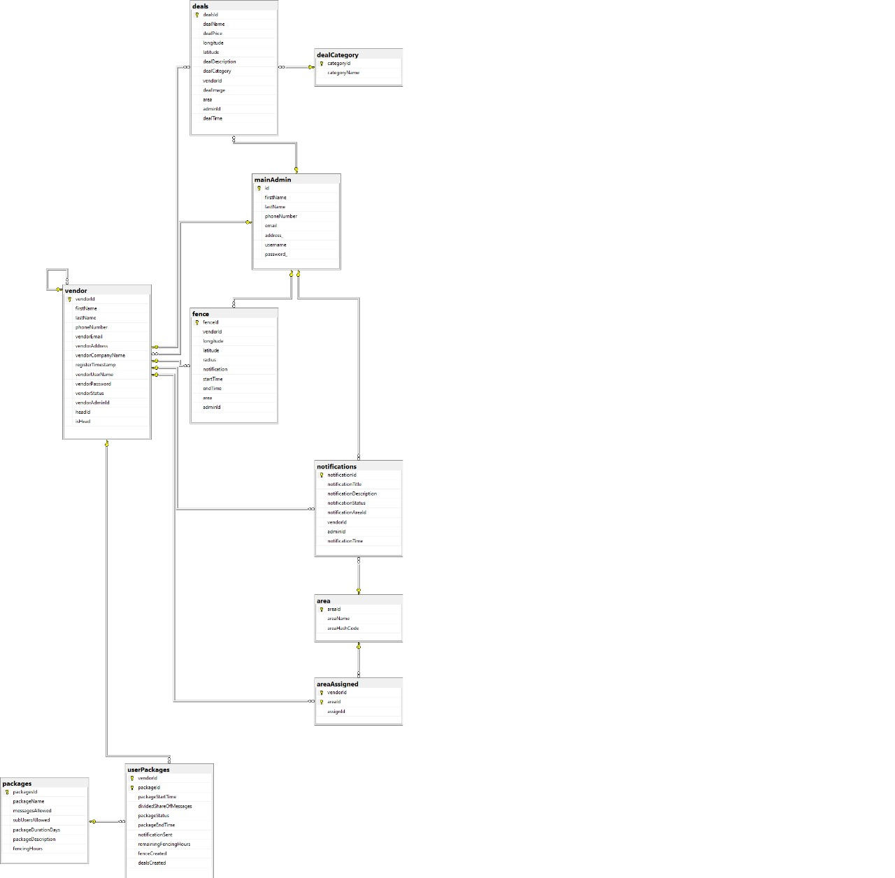

### **Sequence Diagram**

### **Sequence Diagram 1**

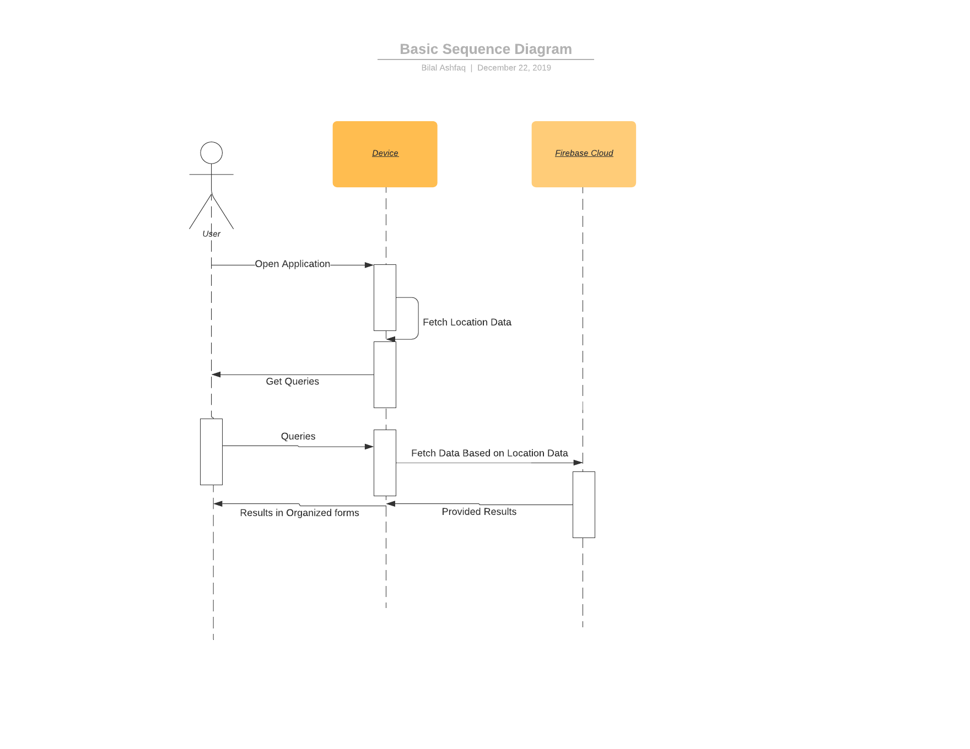

### **Sequence Diagram 2**

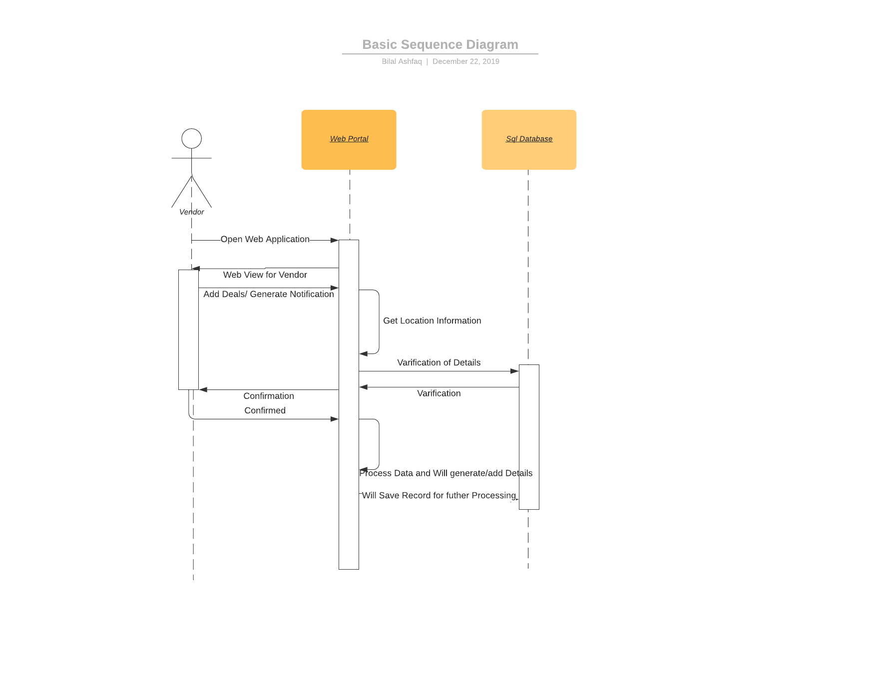

## Implementation Details

### **Development Tools**

Development tools used in this project are mentioned below

### **Firebase**



### **Android Studio**



### **SQL Server**



### **Visual Studio**



### **User Interface**

UI used in this project are included with frameworks, here are some:

1. .NET Web Interface
2. Material UI Android

### **Hardware**

* Processor: Intel Core i3 1 generations and above
* Memory: 4 GB and above
* Storage: 10 GB and above (SSD will be preferable)

### **Software**

Software required to complete this project includes:

* OS: 64-bit Windows 7/10
* JDK, Android Studio, Visual Studio, Oracle VMware, SQL Server 2017, Anaconda Distribution

## Architecture

Hybrid Architecture with the combination of Repository and Client Server is used for increasing flexibility and efficiency.

### **Repository Architecture**

Android Application and Web Application both must exchange data in real-time. This may be done by using Repository Architecture. Repository Architecture will be the shared part between two servers used by our project team.

Each Application maintains its own database and passes data explicitly to each other and will be responsible for changes on the other hand too so that synchronization will take place.

### **Advantages of Repository Architecture**

* Efficient way to share large amounts of data
* Centralized Management that takes control of backup, integrity and security
* Integrate into a different database and maintain the workflow

### **Client-Server Architecture**

Data processing is distributed across multiple clients and Application Servers and also allows clients to access the server from any point of connection, and privilege levels will be maintained at the server level so that data can be confidential and secure.

### **Advantages of Client-Server Architecture**

* Organize the Client and Server in a set of layers each provides a set of services
* Data Encryption attain successfully
* Message broadcast will be easy through a server

### **Diagram Client and Server + Repository Architecture**



## Use Cases

### **User Use Case**

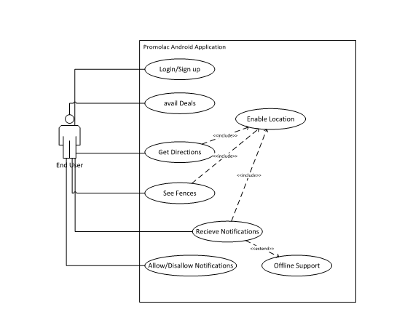

### **Vendor Use Case**

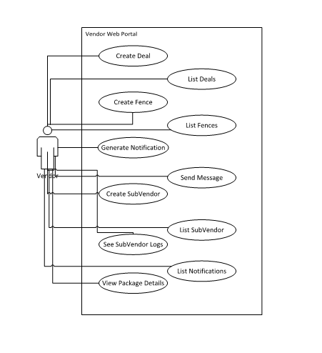

### **Admin Use Case**

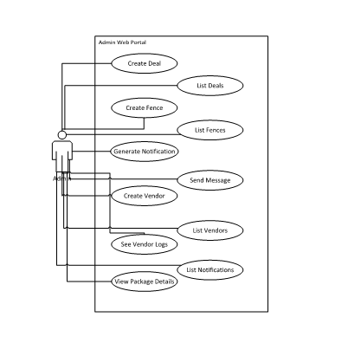

## Test Plan

### **Version History**

|  |  |  |  |  |  |
| --- | --- | --- | --- | --- | --- |
| Version # | Implemented  By | Revision  Date | Approved  By | Approval  Date | Reason |
| 1.1 | Promolac team | 06/06/20 | Mr. Farrukh Hasan | 07/06/20 | Test Plan draft |
|  |  |  |  |  |  |

### **Introduction**

### **Purpose**

The purpose of the testing is to analyses the system errors and problems generated in user experience. Management of web application and android application is optimized by testing. UI defects in Human Computer Interactions and unusual exceptions are mainly the concern. The bugs fixing in privacy and security is crucial for every user to maintain their personal information.

### **Environmental needs**

* Active internet connection to connect Android Application with Firebase and Web Application with SQL server
* Some External Android Devices with location enabled with permission access granted.
* Data will be usually generated for testing by manually user input on Android app as well as Web
* Each module will be tested on every sort of data, and exceptions are properly handled at each point.
* Testing with every aspect will be done to make sure app don’t crash
* No special Power requirements are required as Promolac is a simple system consisting of Android and Web Application.

### **Test Strategy**

### **Test Objectives**

The objective of the test is to verify that the functionality of Promolac works according to the specifications.

The test will execute and verify the test scripts, identify, fix and retest all high and medium severity defects per the entrance criteria, prioritize lower severity defects for future fixing via CR.

The final product of the test is twofold

* A production-ready software
* A set of stable test scripts that can be reused for Functional and validation test execution.

### **Test Assumptions**

**Key Assumptions**

* The data required will be available in the system prior to start of Functional Testing
* In each testing phase, Cycle 3 will be initiated if the defect rate is high in Cycle 2.

**General**

* Exploratory Testing would be carried out once the build is ready for testing
* Performance testing is not considered for this estimation.
* All the defects would come along with a snapshot JPEG format.
* Test case design activities will be performed by Team Members.
* Test environment and preparation activities will be owned by Team.
* Team will provide Defect fix plans based on the Defect meetings during each cycle to plan. The same will be informed to Test team prior to start of Defect fix cycles.
* Supervisors will review and sign-off all Test cases prepared by Test Team prior to start of Test execution
* The defects will be tracked. Any defect fixes planned will be shared with Test Team prior to applying the fixes on the Test environment.
* Project Supervisor will review and sign-off all test deliverables.
* The project will provide test planning, test design and test execution support.
* Test team will manage the testing effort with close coordination with Project Supervisor.
* Project team has the knowledge and experience necessary, or has received adequate training in the system, the project and the testing processes.
* There is no environment downtime during test due to outages or defect fixes.
* The system will be treated as a black box; if the information shows correctly online and, in the reports, it will be assumed that the database is working properly.
* Functional Testing
* During Functional testing, testing team will use preloaded data which is available on the system at the time of execution
* The Test Team will be performing Functional testing on Android and Web Application
* UAT
* UAT test execution will be performed by end users and Group will provide their support on creating UAT script.

### **Test Principles**

* Testing will be focused on meeting the business objectives, cost efficiency, and quality.
* There will be common, consistent procedures for all teams supporting testing activities.
* Testing processes will be well defined, yet flexible, with the ability to change as needed.
* Testing activities will build upon previous stages to avoid redundancy or duplication of effort.
* Testing will be a repeatable, quantifiable, and measurable activity.
* Testing will be divided into distinct phases, each with clearly defined objectives and goals.
* There will be entrance and exit criteria.

### **Data Approach**

* In functional testing, Promolac will contain pre-loaded test data and which is used for testing activities.

### **Scope and Levels of Testing**

**Purpose:**

The purpose of this test is to make sure critical defects are removed before the next levels of testing can start.

**Scope:**

First level navigation, simple communication and every module working according to required condition.

**Testers:**

Group Members

**Method:**

This exploratory testing is carried out in the application without any test scripts and documentation

**Timing:**

At the end of each cycle.

### **Functional Test**

**Purpose:**

Functional testing will be performed to check the functions of application. The functional testing is carried out by feeding the input and validates the output from the application.

**Scope:**

The working of the ever module should be as per required in the documentation. Note: The scope is high level due to changes in the requirement.

**Testers:**

Inam, Bilal, Ammar, Arslan, Muzammil and Afroz

**Method:**

The test will be performed according to Functional scripts and analyzing multiple aspect of the module.

**Timing:**

After Exploratory test is completed.

### **Test Acceptance Criteria**

* Approved Functional Specification document, Use case documents must be available prior to start of Test design phase.
* Test cases approved and signed-off prior to start of Test execution
* Development completed, unit tested with pass status and results shared to Testing team to avoid duplicate defects
* Test environment with application installed, configured and ready to use state

### **Test Deliverables**

|  |  |  |  |
| --- | --- | --- | --- |
| **No.** | **Deliverable Name** | **Author** | **Reviewer** |
| 1. | Test Plan | Group Members | Supervisor/Jury |
| 2. | Functional Test | Group Members | Supervisor and team leader |
| 3. | Unit Testing | Group Members | Supervisor |
| 4. | System testing | Group Members | Supervisor |
| 5. | Test Closure report | Group Members | Supervisor |

### 

### **Milestone List**

The milestone list is tentative and may change due to below reasons

* Any issues in the System environment readiness
* Any change in scope/addition in scope
* Any other dependency that impacts efforts and timelines

### **User Acceptance Test (UAT)**

**Purpose:**

this test focuses on validating the business logic. It allows the end users to complete one final review of the system prior to deployment.

**Testers:**

Normal people along with the Special People.

**Method:**

Since the Normal and special users are the most indicated to provide input around business needs and how the system adapts to them, it may happen that the users do some validation not contained in the scripts. Test team write the UAT test cases based on the inputs from End user.

**Timing:**

After all other levels of testing (Exploratory and Functional) are done. Only after this test is completed the product can be released to production.

### **Validation and Defect Management**

* It is expected that the testers execute all the scripts in each of the cycles described above. However, it is recognized that the testers could also do additional testing if they identify a possible gap in the scripts. This is especially relevant in the second cycle, when the leap motion module will be testing for their accuracy with having a deeper knowledge of the Sign Language. If a gap is identified, the functionality and the data set will be updated and then a defect logged against the scripts.
* It is the responsibility of the tester to open the defects, link them to the corresponding script, assign an initial severity and status, retest and close the defect; it is the responsibility of the Tester to review the severity of the defects and facilitate with the development team the fix and its implementation, communicate with testers when the test can continue or should be halt, request the tester to retest, and modify status as the defect progresses through the cycle; it is the responsibility of the technical team to review, fix the defect, communicate to the Defect Manager the fix is done, implement the solution per the Defect Manager request.
* Defects found during the Testing will be categorized according to the bug-reporting tools and the categories are

|  |  |
| --- | --- |
| **Severity** | **Impact** |
| 1 (Critical) | * This bug is critical enough to crash the system, cause file corruption, or cause potential data loss. * It causes an abnormal return to the operating system (crash or a system failure message appears). * It causes the application to hang and requires re-booting the system. |
| 2 (High) | * It causes a lack of vital program functionality with workaround. |
| 3 (Medium) | * This Bug will degrade the quality of the System Reducing the accuracy of the system. However, there is an intelligent workaround for achieving the desired functionality. * This bug prevents other areas of the product from being tested. However other areas can be independently tested. |
| 4 (Low) | * There is an insufficient or unclear error message, which has minimum impact on product use. |
| 5(Cosmetic) | * There is an insufficient or unclear error message that has no impact on product use. |

### **Defect tracking & Reporting**

Following flowchart depicts Defect Tracking Process:

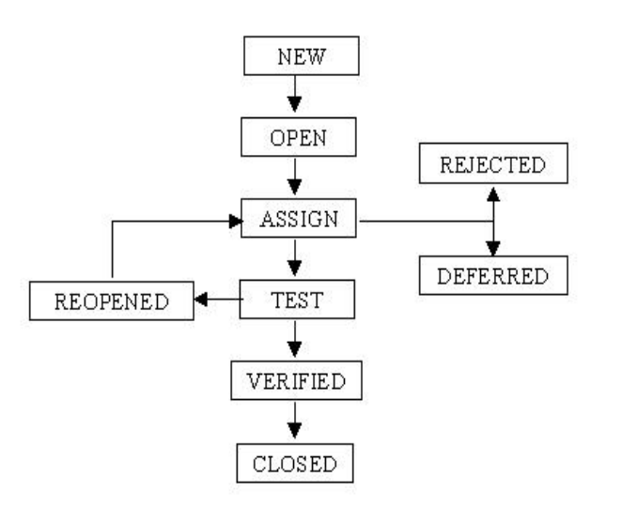

### **Test Management Process**

### **Test Design Process**

* The tester will understand each requirement and prepare corresponding test case to ensure all requirements are covered.
* Each Test case will be mapped to Use cases to Requirements as part of Traceability matrix.
* Each of the Test cases will undergo review and the review defects are captured and shared to the Test team. The testers will rework on the review defects and finally obtain approval and sign-off.
* During the preparation phase, tester will use the prototype, use case and functional specification to write step by step test cases.
* Testers will maintain a clarification Tracker sheet and same will be shared periodically with the Requirements team and accordingly the test case will be updated. The clarifications may sometimes lead to Change Requests or not in scope or detailing implicit requirements.
* Sign-off for the test cases would be communicates through mail by Business Analyst’s.
* Any subsequent changes to the test case if any will be directly updated.

### **Test Execution Process**

* Once all Test cases are approved and the test environment is ready for testing, tester will start an exploratory test of the application to ensure the application is stable for testing.
* Each Tester is assigned Test cases directly.
* Testers to ensure necessary access to the testing environment and updating test status and raise defects. If any issues, will be escalated to the Test Lead and in turn to the Project Manager as escalation.
* If any showstopper during exploratory testing will be escalated to the respective development SPOCs for fixes.
* Each tester performs step by step execution and updates the executions status. The tester enters Pass or Fail Status for each of the step directly.
* Tester will prepare a Run chart with day-wise execution details
* If any failures, defect will be raised as per severity guidelines detailing steps to simulate along with screenshots if appropriate.
* Testing team will participate in defect triage meetings in order to ensure all test cases are executed with either pass/fail category.
* This process is repeated until all test cases are executed fully with Pass/Fail status.

As per Process, final sign-off or project completion process will be followed

### **Test Risks and Mitigation Factors**

| Risk | Prob. | Impact | Mitigation Plan |
| --- | --- | --- | --- |
| **SCHEDULE**  Testing schedule is tight. If the start of the testing is delayed due to design tasks, the test cannot be extended beyond the UAT scheduled start date. | High | High | The testing team can control the preparation tasks (in advance) and the early communication with involved parties.  Some buffer has been added to the schedule for contingencies, although not as much as best practices advise. |
| **RESOURCES**  Not enough resources, resources on boarding too late (process takes around 6 months | High | High | Holidays and vacation have been estimated and built into the schedule; deviations from the estimation could derive in delays in the testing. |
| **DEFECTS**  Defects are found at a late stage of the cycle or at a late cycle; defects discovered late are most likely be due to unclear specifications and are time consuming to resolve. | Medium | High | Defect management plan is in place to ensure prompt communication and fixing of issues. |
| **SCOPE**  Scope completely defined | Low | Medium | Scope is well defined but the changes are in the functionality are not yet finalized or keep on changing. |
| Natural disasters | Low | Medium | Teams and responsibilities have been spread to two different geographic areas. In a catastrophic event in one of the areas, there will resources in the other areas needed to continue (although at a slower pace) the testing activities. |
| Non-availability of Independent Test environment and accessibility | Medium | High | Due to non-availability of the environment, the schedule gets impacted and will lead to delayed start of Test execution. |
| Delayed Testing Due to New Issues | High | High | During testing, there is a good chance that some “new” defects may be identified and may become an issue that will take time to resolve.  There are defects that can be raised during testing because of unclear document specification. These defects can yield to an issue that will need time to be resolved.  If these issues become showstoppers, it will greatly impact on the overall project schedule.  If new defects are discovered, the defect management and issue management procedures are in place to immediately provide a resolution. |

### 

### **Test Environment**

* Promolac App will be hosted at Firebase.
* Promolac Web Portal will be hosted on online server.
* Promolac will be hosted on two servers: One to host the actual website and (language) code, and the other will be connected to it.
* A windows environment with and with Firefox 27.0 or later, Internet Explorer 8, 9 and 10, as well as Google Chrome 32.0 and later should be available to each tester
* The JDK and SDK 3.0 or later should be installed. The tester hand should have internet connectivity and location service enabled. The tester should have android device having android 5.0 and above. Tester should have Visual Studio download on his PC or Laptop. Tester should have SQL Server Management Studio and Firebase.

### **Test Cases**

### **User Test Case:**

**Test 1:**

|  |  |  |  |  |  |
| --- | --- | --- | --- | --- | --- |
| **TEST CASE ID: PRL001**  **DESCRIPTION: User Login Check (Android Application)** | | | | | |
| **No.** | **STEPS** | **EXPECTED RESULTS** | **ACTUAL RESULTS** | **PASS/ FAIL** |
|  | Correct id and password | Successful Login | Successfully login | Pass |
|  | Correct id, Wrong password | Show Error (Wrong Id Exception) | Login denied with error message | Pass |
|  | Wrong id and password | Show Error (Wrong id and password Error) | Login denied with error message | Pass |
|  | Wrong id, Correct password | Show Error (Wrong password Error) | Login denied with error message | Pass |
|  | Empty Password or Username | Empty Field Prompt | App Crashed | Fail |
|  | Empty Password or Username (updated) | Empty Field Prompt | Empty Field Prompt | Pass |

**Test 2:**

|  |  |  |  |  |  |
| --- | --- | --- | --- | --- | --- |
| **TEST CASE ID: PRL002**  **DESCRIPTION: User Signup Check (Android Application)** | | | | | |
| **No.** | **STEPS** | **EXPECTED RESULTS** | **ACTUAL RESULTS** | **PASS/ FAIL** |
|  | Register new account | Register Successful | Register Successfully | Pass |
|  | Register by using used Email | Show Error (Already Register Prompt) | Successfully Registered | Fail |
|  | Register by using used Email | Show Error (Already Register Prompt) | Login denied with error message | Pass |
|  | Register by using wrong email without domain address | Email Address is in wrong pattern | Nothing happened User Register Successfully | Fail |
|  | Register by using wrong email without domain address | Email Address is in wrong pattern | Nothing happened | Fail |
|  | Register by using wrong email without domain address | Email Address is in wrong pattern prompt | Email Address is in wrong pattern prompt | Pass |
|  | Empty Password or Name or Email | Empty Field Prompt | App Crashed | Fail |
|  | Empty Password or Name or Email | Empty Field Prompt | Empty Field Prompt | Pass |

**Test 3:**

|  |  |  |  |  |  |
| --- | --- | --- | --- | --- | --- |
| **TEST CASE ID: PRL003**  **DESCRIPTION: Upload Profile (Android Application)** | | | | | |
| **No.** | **STEPS** | **EXPECTED RESULTS** | **ACTUAL RESULTS** | **PASS/ FAIL** |
|  | Upload Profile | Upload Successful | Upload Successfully | Pass |
|  | Checking Upload on Firebase | Upload Successfully | No Record Found | Fail |
|  | Checking Upload on Firebase (again) | Upload Successfully | Uploading Error in App | Fail |
|  | Checking Upload on Firebase (again) | Upload Successfully | App Crashed | Fail |
|  | Checking Upload on Firebase (again) | Upload Successfully | Upload Successfully | Pass |

**Test 4:**

|  |  |  |  |  |  |
| --- | --- | --- | --- | --- | --- |
| **TEST CASE ID: PRL004**  **DESCRIPTION: Deal List View Test (Android Application)** | | | | | |
| **No.** | **STEPS** | **EXPECTED RESULTS** | **ACTUAL RESULTS** | **PASS/ FAIL** |
|  | Deals Added | Deals will be Show Correctly | Last Deal is not shown completely | Fail |
|  | Deals Added | Deals will be Show Correctly | First Deal is not shown completely | Fail |
|  | Deals Added | Deals will be Show Correctly | Deal Show Correctly | Pass |
|  | Deals Image Downloading | Download Successfully | App Crashed | Fail |
|  | Deals Image Downloading | Download Successfully | Downloaded Successfully | Pass |
|  | Checking Upload on Firebase | Upload Successfully | App Crashed | Fail |
|  | Checking Upload on Firebase | Upload Successfully | Upload Successfully | Pass |

**Test 5:**

|  |  |  |  |  |  |
| --- | --- | --- | --- | --- | --- |
| **TEST CASE ID: PRL005**  **DESCRIPTION: Message List View Test (Android Application)** | | | | | |
| **No.** | **STEPS** | **EXPECTED RESULTS** | **ACTUAL RESULTS** | **PASS/ FAIL** |
|  | Messages Added | Messages will be Show Correctly | Last Message is not shown completely | Fail |
|  | Messages Added | Messages will be Show Correctly | First Message is not shown completely | Fail |
|  | Message Added | Message will be Show Correctly | Message Show Correctly | Pass |
|  | Message Downloading | Download Successfully | App Crashed | Fail |
|  | Message Downloading | Download Successfully | Downloaded Successfully | Pass |
|  | Checking Upload on Firebase | Upload Successfully | App Crashed | Fail |
|  | Checking Upload on Firebase | Upload Successfully | Upload Successfully | Pass |
|  | Checking save in file | Saved in File | Not saved in file | Fail |
|  | Checking save in file | Saved in File | Saved in File | Pass |
|  | Delete Message | Delete Successfully | Not Deleted | Fail |
|  | Delete Message | Delete Successfully | Not Deleted | Pass |

### **Vendor/Admin Test Cases**

**Test Case 1**

|  |  |  |  |  |
| --- | --- | --- | --- | --- |
| **TEST CASE ID:  PRLV001**  **DESCRIPTION: Vendor/Admin login on Web Portal** | | | | |
| **No.** | **STEPS** | **EXPECTED RESULTS** | **ACTUAL RESULTS** | **PASS/ FAIL** |
|  | Authentic Id and Password | Successful Login | Successfully Login | pass |
|  | Correct Id but wrong Password | Access Denied with Error message | Access Denied | pass |
|  | Correct password with wrong ID | Access Denied with Error message | Access Denied | pass |
|  | Both Id and password wrong | Access Denied with Error message | Access Denied | pass |
|  | Empty Id/Password | Field Required Prompt | Fields Required Prompt | pass |

**Test Case 2**

|  |  |  |  |  |
| --- | --- | --- | --- | --- |
| **TEST CASE ID:  PRLV002**  **DESCRIPTION: Package and Trying to Access** | | | | |
| **No.** | **STEPS** | **EXPECTED RESULTS** | **ACTUAL RESULTS** | **PASS/ FAIL** |
|  | Package available | Successful Login | Successfully Login | pass |
|  | Package expired | Access Denied with Error message | Access Denied | pass |

**Test Case 3**

|  |  |  |  |  |
| --- | --- | --- | --- | --- |
| **TEST CASE ID:  PRLV003**  **DESCRIPTION: Deals Create** | | | | |
| **No.** | **STEPS** | **EXPECTED RESULTS** | **ACTUAL RESULTS** | **PASS/ FAIL** |
|  | Deal Create with Package available | Successful Create | Successfully Created | pass |
|  | Deal Create with Package bucket expired | Create Deny | Create Denied | pass |

**Test Case 4**

|  |  |  |  |  |  |
| --- | --- | --- | --- | --- | --- |
| **TEST CASE ID:  PRLV004**  **DESCRIPTION: Geofence Create** | | | | | |
| **No.** | **STEPS** | **EXPECTED RESULTS** | **ACTUAL RESULTS** | **PASS/ FAIL** |
|  | **Fence Create with Package available** | **Successful Create** | **Successfully Created** | **pass** |
|  | **Fence Create with Package bucket expired** | **Create Deny** | **Create Denied** | **pass** |

**Test Case 5**

|  |  |  |  |  |
| --- | --- | --- | --- | --- |
| **TEST CASE ID:  PRLV005**  **DESCRIPTION: Send Notification** | | | | |
| **No.** | **STEPS** | **EXPECTED RESULTS** | **ACTUAL RESULTS** | **PASS/ FAIL** |
|  | Send Notification with Package available | Successful Notification send | Successfully Sent | pass |
|  | Send Notification with Package bucket expired | Send Notification Deny | Send Notification Denied | pass |

**Test Case 6**

|  |  |  |  |
| --- | --- | --- | --- |
| **TEST CASE ID:  PRLV006**  **DESCRIPTION: Send Message** | | | |
| **No.** | **STEPS** | **EXPECTED RESULTS** | **ACTUAL RESULTS** | **PASS/ FAIL** |
|  | Send Message with Package available | Successful Message send | Successfully Sent | pass |
|  | Send Message with Package bucket expired | Send Message Deny | Send Message Denied | pass |

**Test Case 7**

|  |  |  |  |  |
| --- | --- | --- | --- | --- |
| **TEST CASE ID:  PRLV007**  **DESCRIPTION: Create Sub Vendor** | | | | |
| **No.** | **STEPS** | **EXPECTED RESULTS** | **ACTUAL RESULTS** | **PASS/ FAIL** |
|  | Create Sub Vendor limited by Package | Successful Create | Successfully Created | pass |
|  | Create Sub Vendor in Empty bucket | Create Deny | Denied | pass |

## Future Work

In future we will implement location-based group chat in mobile application and two of our work Geo-Conquesting and Beacons-Technology. User experience will get major upgrade by applying Machine Learning to learn user pattern.

## Conclusion

A software which can help companies to get marketing services of their product’s in real life. Our goal is to make something for them that can make their life easy. Our aim is to target that kind of people and contribute in society with our product. Promolac system for e-marketing using location details was successfully executed with high accuracy. The method gives output in push notifications and message updates that helps to reduce the marketing gap between companies and end users. Thus, the implementation of system output is done in Android and Python.